Driver Drowsiness Detection

A Project Report

Submitted by

Mihika Nigam (189302103)
Khushi Shrivastava (189303083)
Akshat Sachan (189403035)

In partial fulfilment for the award of the degree

of

BACHELOR OF TECHNOLOGY

IN

Information Technology and Computer and communication

At



MANIPAL UNIVERSITY JAIPUR

JAIPUR

November 2020

DECLARATION BY THE CANDIDATE

I hereby declare that the work, which is going to be presented in the Project, entitled “Driver Drowsiness Detection” to be submitted in partial fulfilment of the requirement for the award of Degree of “Bachelors of Technology” in Department of Information Technology with Specialization in Microprocessor and Microcontroller and to be submitted to the Department of Information Technology, Manipal University Jaipur is an authentic record of my own investigations carried out under the supervision of Dr. Vivek K Verma , Assistant Professor, SCIT, Manipal University Jaipur.
I have not submitted the matter presented in this project anywhere for the award of any other degree.

Akshat Sachan Mihika Nigam Khushi Shrivastava
189403035 189302103 189303083

ACKNOWLEDGEMENT

The enduring pages of the work are the cumulative sequence of extensive guidance and arduous work. I wish to acknowledge and express my personal gratitude to all those without whom this work could not have been reality.

I feel very delighted to get this rare opportunity to show my profound senses of reverences and indebtedness to my esteemed Dr. Vivek K Verma for his keen and sustained interest, valuable advice, throughout the course of which led my report, to a successful completion. For this kind act of consideration, I be holder to him in special manner and no one can fully convey my feelings of respect and regard for them.

LIST OF FIGURES

Figure 1.1 | Flow chart of algorithm 3
Figure 3.1 | Snapshot from video 7
Figure 3.2 | Detected face 7
Figure 3.3 | Image of eyes open 7
Figure 3.4 | Binary image of open eye 7
Figure 3.5 | Image of eyes closed 7
Figure 3.6 | Binary image of closed eye 7
Figure 3.7 | Image of closed mouth 8
Figure 3.8 | Binary image of closed mouth 8
Figure 3.9 | Image of mouth open 8
Figure 3.10 | Binary image of open mouth 8
Figure 3.11 | Image before skin segmentation 9
Figure 3.12 | Image after skin segmentation 9
Figure 3.13 | Head lowering image 9
Figure 3.14 | Screenshot of Result of head lowering 9
Figure 3.15 | Head is not lowered 9
Figure 3.16 | Screenshot of Result when head is not lowered 9

TABLE OF CONTENTS

PARTICULARS |  |  | Page
Candidate’s Declaration |  |  | ii
Acknowledgement |  |  | iii
List of Figures |  |  | iv
Abstract |  |  | 1
1 | Introduction |  | 2
 | 1.1 | Background | 2
 | 1.2 | Project Motivation | 2
 | 1.3 | Aims and Objectives | 3
 | 1.4 | Flow chart | 3
2 | Implementation |  | 4
 | 2.1 | Tools & Technology | 4
 | 2.2 | Instruction used and Description | 5
3  4 | Result Analysis  Conclusion |  | 7  10
References |  |  | 11

ABSTRACT
This project will be developed using MATLAB and can be summarized as driver drowsiness detection and driver safety system which uses image processing techniques. The system will be detecting driver drowsiness with webcam and machine learning algorithms to develop a Smart Driver Assistance System to alert the driver. The system uses information obtained from binary version of the image (detected with the help of Viola Jones Algorithm), to find the edges of the face which narrows down to EYES and MOUTH. Measuring the distance between the intensity changes in the eye area determines whether the eyes are open or closed. If the eyes are closed for more than a number of threshold consecutive frames, the system draws the conclusion that the driver is drowsy. This works with the mouth too, to detect if the person is yawning. The system also generates warning when the head is lowered or turned in the wrong direction. This increases the probability of preventing accidents.

Chapter - 1
INTRODUCTION
  - Background
Each year hundreds of people lose their lives due to traffic accidents around the world.
Unfortunately, India ranks 1st in the number of road accident deaths across the 199 countries reported in the World Road Statistics, followed by China and US. As per the WHO Global Report on Road Safety, India accounts for almost 11% of the accident related deaths in the World. According to national statistics, in 90 to 95 percent of car accidents, the human factor plays a pivotal role and thus the role of the human factor in traffic accidents cannot be ruled out. In general, driver fatigue accounts for 25% of accidents and almost 60% of the accidents result in death or fatal injuries.

Exhausted drivers who doze off at the wheel are responsible for about 40% of road accidents, says a study by the Central Road Research Institute (CRRI) on the 300-km Agra-Lucknow Expressway. The scale of accidents is severe considering this is the case of only a single highway in India. A main cause of fatigue in drivers is drowsiness.

One possible method to check driver fatigue is monitoring the physical condition, facial expression and head movements and transmitting this information to an alert system with adequate precision.

1.2 Project Motivation
Driving is almost as common as eating food in most people’s lives now-a-days. Thus, making driving as safe as possible is an utmost priority. Despite improving vehicle designs and driver awareness, the total number of traffic accidents is not decreasing. The reason is impairments in the driver’s attention.
Therefore, driver drowsiness being within our scope and an issue of importance resulted in us creating a driver drowsiness detection system using concepts of image processing.

1.3 Aims and Objectives
The aim of this thesis is to contribute to the study of driver behaviour while driving, through the development and evaluation of a drowsiness driver model system. The result from the research will be integrated to produce the systems that can be efficient in detecting the drowsiness level at an early stage by giving a warning to them about their lack of attention due to drowsiness or other factors. In other words, they can correct the behaviour or stop driving when they are in the drowsiness state.
1.4 Flow chart
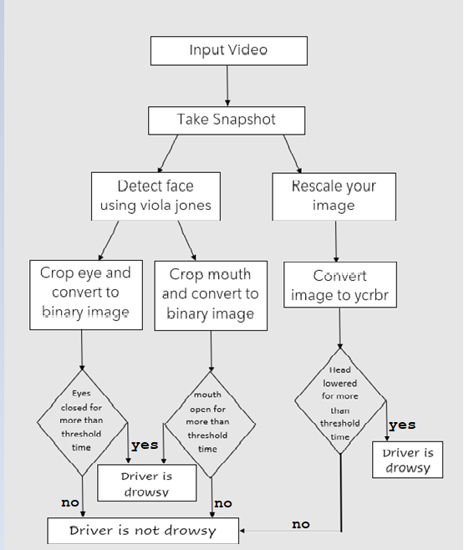
Fig 1.1 flow chart of algorithm
Chapter - 2
IMPLEMENTATION
2.1 Tools and Technology Used
The project was built using matlab. We used simple matlab R2020b functions to process our input video. Below is a detailed description of all the components used along with their functionality.

- VideoReader(file name)
  - It reads the input video
- read(vid obj, frame no.)
  - It takes a snapshot from the video of the mentioned frame number.
- FrameRate
  - It calculates the rate of input video object
- Duration
  - It calculates the duration of the video object
- vision.CascadeObjectDetector()
  - This is a face detection object which is based on the algo of viola jones.
- step(detection object, input image)
  - This forms a bounding box around the area detected by the detection object.
- imcrop()
  - This is a cropping tool
- size()
  - it gives the array size
- rgb2gray(input image)
  - It is a direct function to convert an image from rgb to grayscale.
- imbinarize(input image)
  - It is a direct function to convert a gray image to binary scale.
- nnz(input image)
  - calculates the number of black pixels in image
- numel(input image)
  - calculates total pixels in image
- zeroes(array size)
  - creates an array filled with zeroes.
- resize(input image, dimensions)
14.1. it scales the image as per our needs
- rgb2hsv(input image)
14.2. it converts image into its hsv counterparts.
2.2 Instruction Used and Description
Face Detection using Voila Jones Algorithm

The Viola–Jones object detection framework is the first object detection framework to provide competitive object detection rates in real-time. Although it can be trained to detect a variety of object classes, it was motivated primarily by the problem of face detection.

In the detection phase of the Viola–Jones object detection framework, a window of the target size is moved over the input image, and for each subsection of the image the Haar-like feature is calculated.
This difference is then compared to a learned threshold that separates non-objects from objects.

Eyes and Mouth Detection

After the face is detected using Voila-Jones, the region containing the eyes and mouth must be separated.
To detect the coordinate from where the region of eye is starting certain calculations are done. After the rectangular window is extracted, we have considered that the eyes are located at (0.25 * height of window) from the top and (0.15 * width of window) from the left.
The size of window is (0.25 * height of window) in height and (0.68 * width of window) in width. Then image is converted to grayscale and ultimately to binary image. Using similar concept mouth is cropped and converted to grayscale.

The first frame is used as reference. All the results are calculated taking first frame as ideal frame.
Eyes Closed: When eyes are closed, the number of black pixels in binary image decreases considerably. If eyes are found closed for at least 2 consecutive seconds, then the warning will be generated.
Mouth Open: When mouth is open, the resulting black pixels in binary image can be considerably larger than the ideal frame. The difference can be more than 6% of the black pixels in ideal frame.
If mouth is found open for at least 2 consecutives, it means that the person is yawning and in response the warning will be generated.

Skin Segmentation

An image which is taken inside a vehicle includes the driver’s face. Typically, a camera takes images within the RGB model (Red, Green and Blue). However, the RGB model includes brightness in addition to the colours. When it comes to human’s eyes, different brightness for the same colour means different colour.
When analysing a human face, RGB model is very sensitive in image brightness. Therefore, to remove the brightness from the images is second step. We use the YCbCr space since it is widely used in video compression standards. Since the skin-tone colour depends on luminance, we nonlinearly transform the YCbCr colour space to make the skin cluster luma-independent. This also enables robust detection of dark and light skin tone colours. The main advantage of converting the image to the YCbCr domain is that influence of luminosity can be removed during our image processing.
In the RGB domain, each component of the picture (red, green and blue) has a different brightness. However, in the YCbCr domain all information about the brightness is given by the Y component, since the Cb (blue) and Cr (red) components are independent from the luminosity.

The first frame is used as reference. All the results are calculated taking first frame as ideal frame.

Head Lowering: If the head is lowered or turned around the number of skin pixels considerably decrease as compared to the ideal frame.
If head is found lowered or found turned in other directions for at least 2 consecutive seconds, it means that the person is vulnerable for accident and in response the warning will be generated.

Chapter - 3
Result Analysis

Face detection:

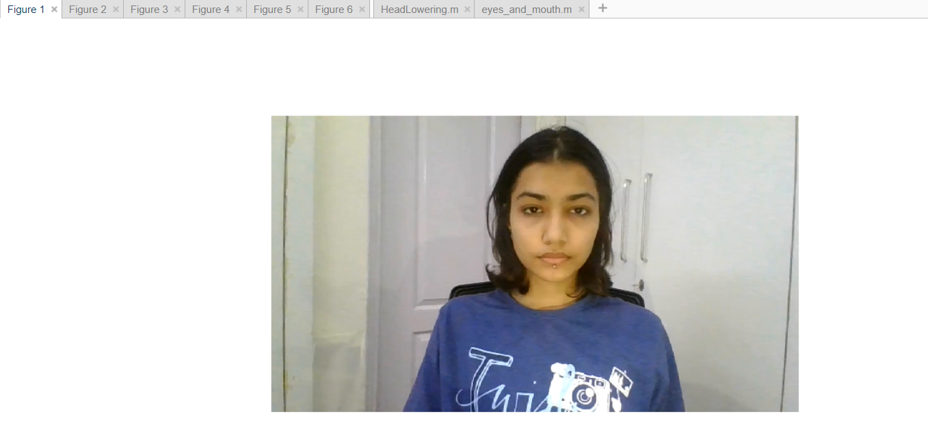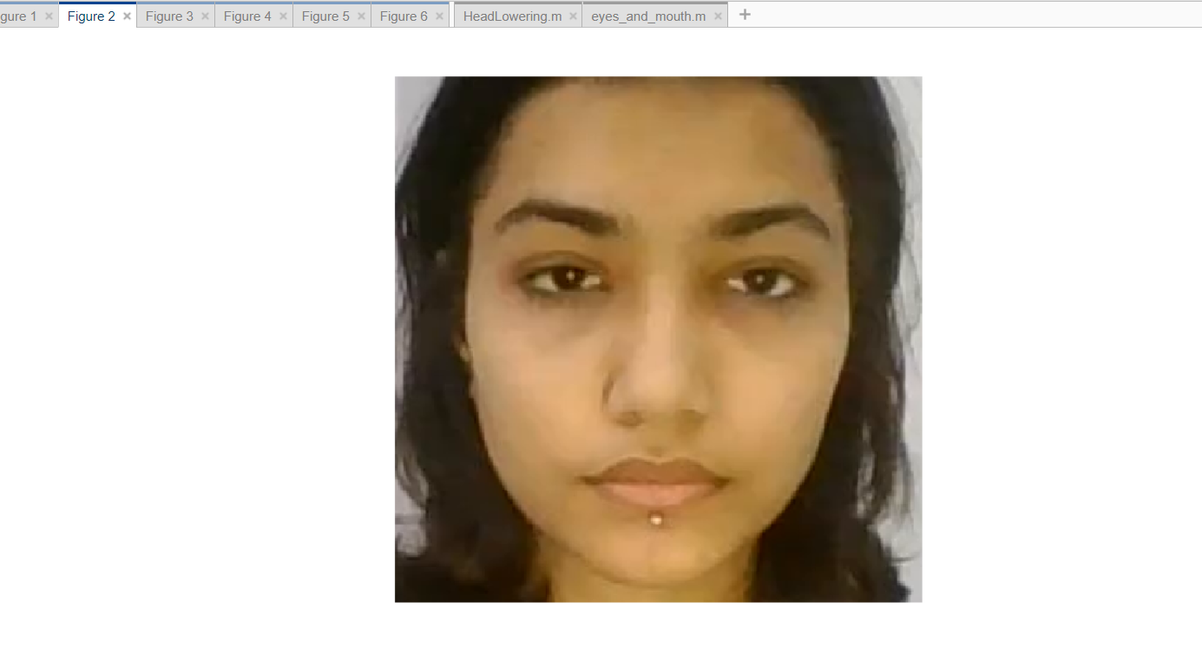
Fig 3.1 Snapshot from the video Fig 3.2 Cropped face after face detection

Eyes and Mouth cases:

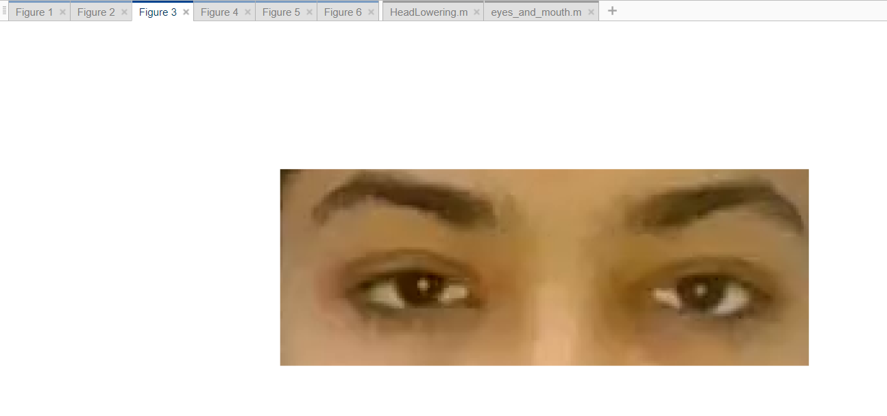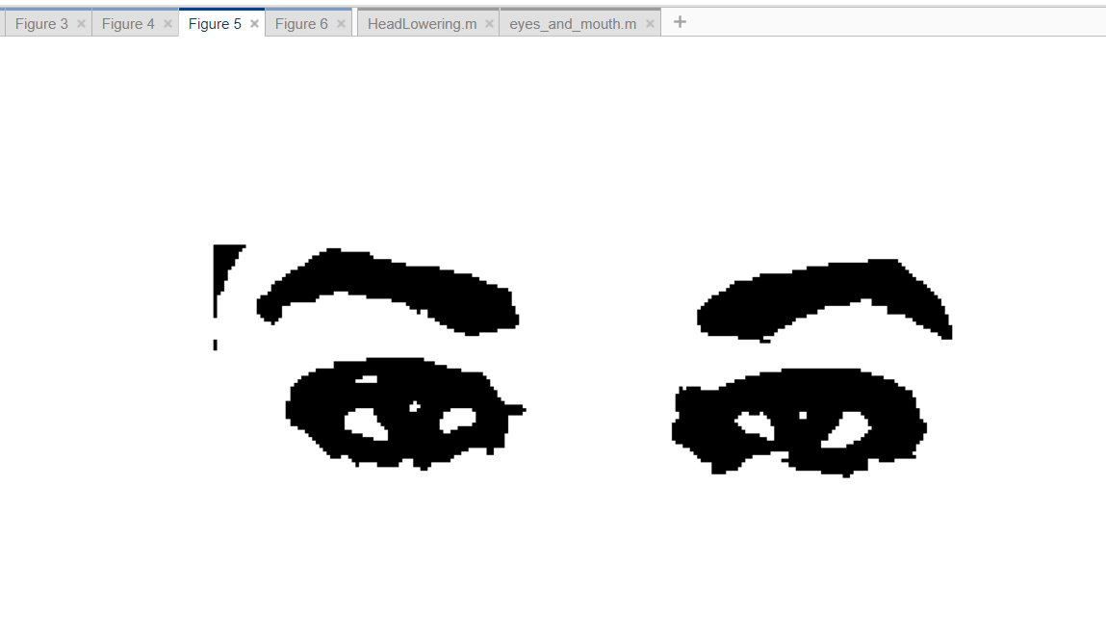
Fig 3.3 original image of eyes open Fig 3.4 binary image of eye (black pixel=23.35%)

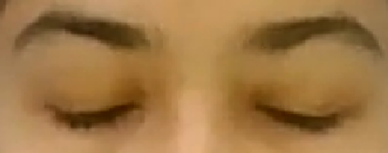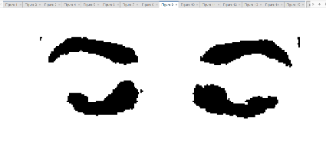
Fig 3.5 Original image of eyes closed
Fig 3.6 Binary image of the eye (black pixels=23.35%)

Here the eyes in fig 3.4 has the reference %age of black pixels. The fig 3.6 has lower black pixel percentage than the reference value so it can be concluded that the eyes are closed for this frame

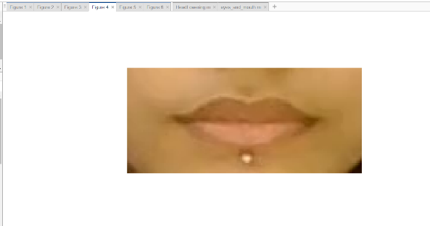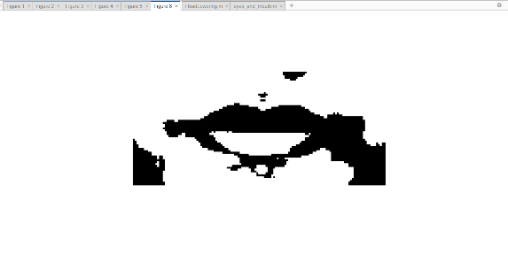
Fig 3.8 binary image of mouth (black pixel=32.82%)
Fig 3.7 original image of closed mouth closed

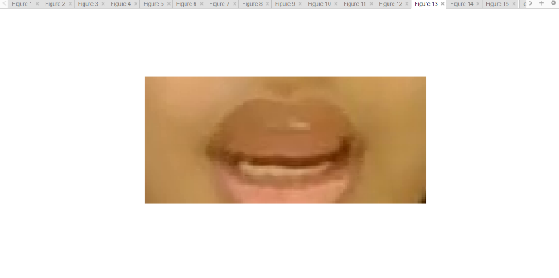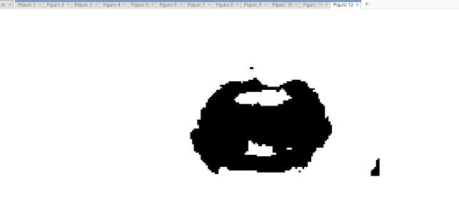
Fig 3.10 Binary image of mouth (black pixels=36.29%)

Fig 3.9 Original image of mouth closed

Here the mouth in fig 3.8 has the reference %age of black pixels. The fig 3.10 has higher black pixel percentage than the reference value so it can be concluded that the mouth is open for this frame.

Head Lowering

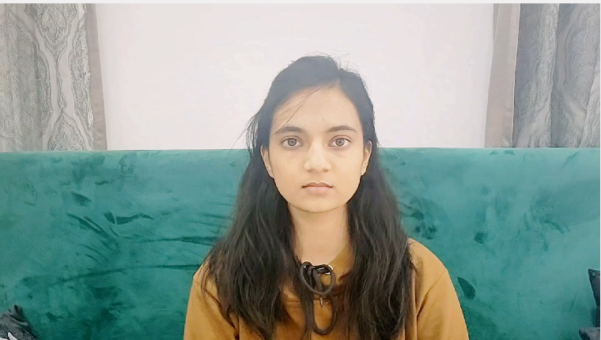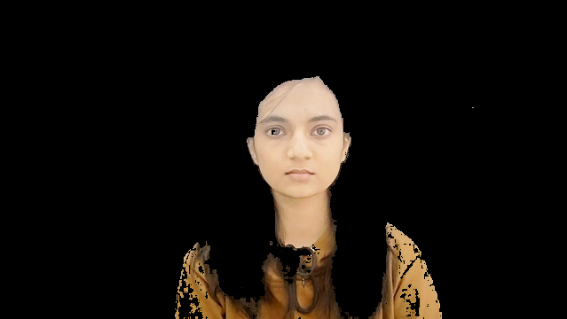
Fig 3.11 image of before skin segmentation Fig 3.12 image after skin segmentation

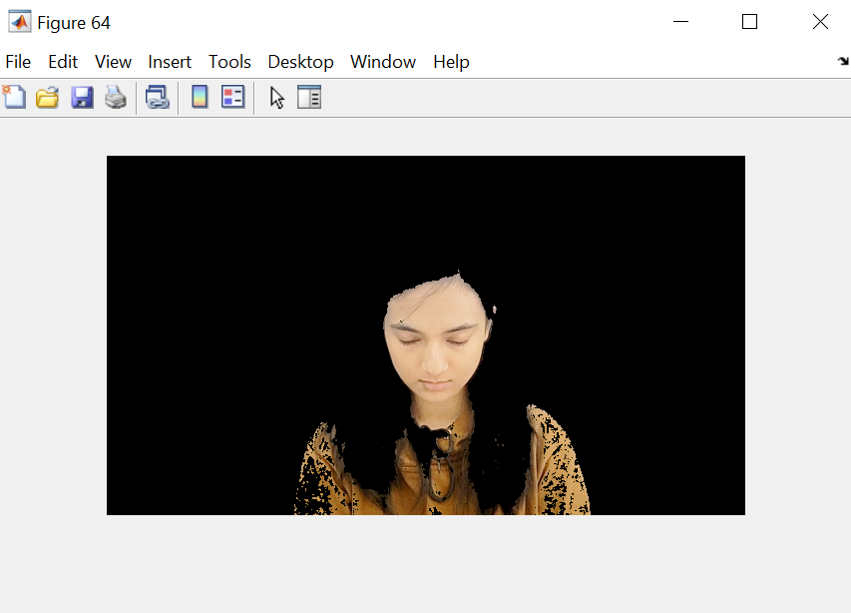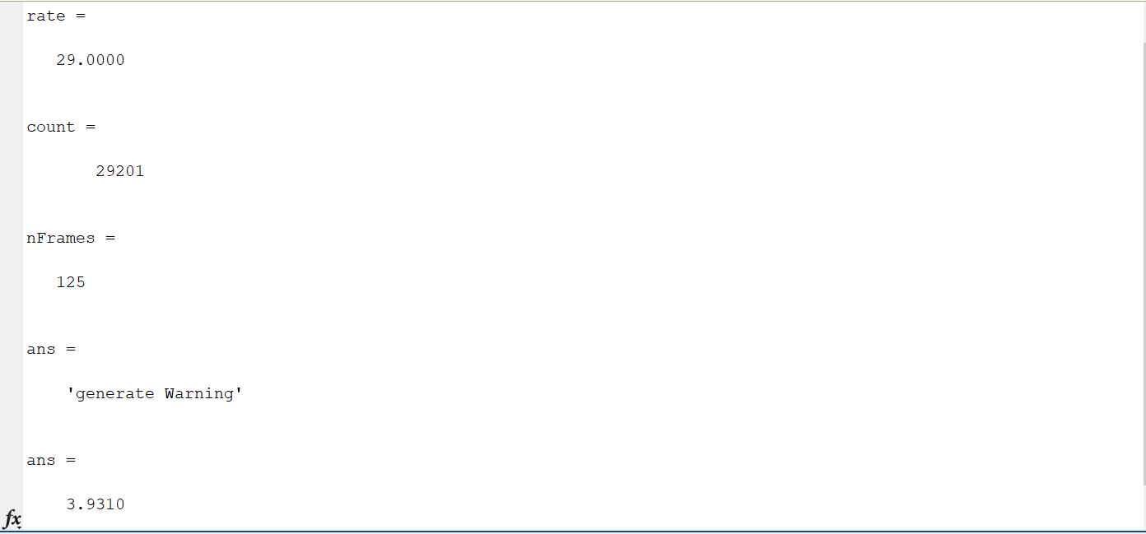
Fig 3.13 Head is lowered Fig 3.14 result when is lowered

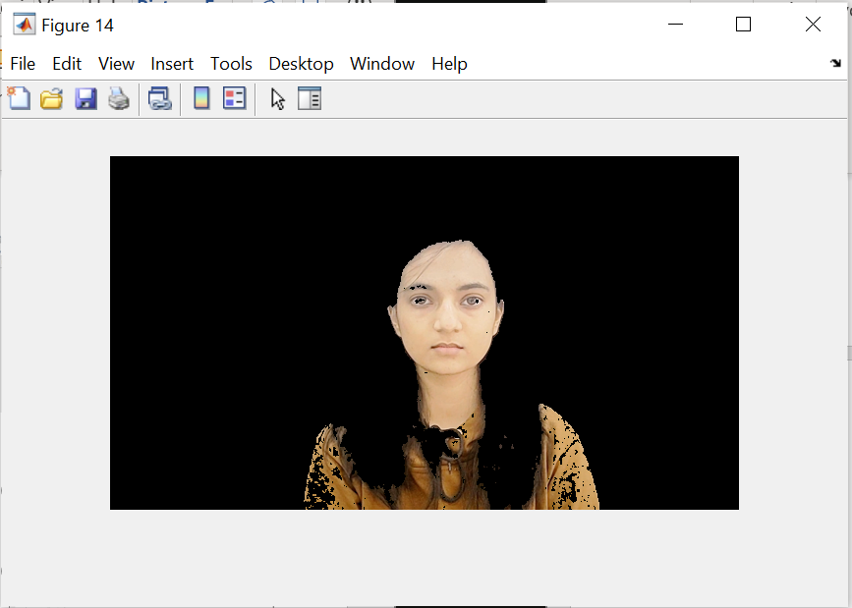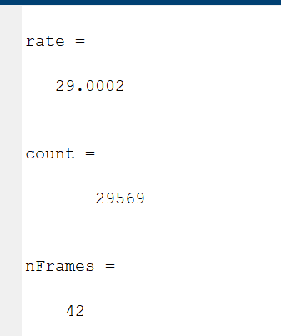
Fig 3.15 Head is not lowered Fig 3.16 result when head is not lowered
Chapter - 4
Conclusion
The drowsiness detection and correction system developed can detect drowsiness in a rapid manner. The algorithm does not work for people sleeping with eyes open. Also, the system may give unreliable results in case of a bald person or an eyelid-less person. The system was developed using most general approximations of the face which is true for 85% of the population. The system which can differentiate normal eye blink and drowsiness which can prevent the driver from entering the state of sleepiness while driving. The system works well even in case of drivers wearing spectacles and under low light conditions also. During the monitoring, the system is able to decide if the eyes are opened or closed. When the eyes have been closed for about two seconds, the alarm beeps to alert the driver. The system was checked against 5 different videos resulting in 4 correct judgements giving around 86% accuracy. By doing this many accidents will be reduced and provide safe life to the driver and vehicle safety. A system for driver safety and car security is presented only in the luxurious costly cars. Using drowsiness detection systems, driver safety can be implemented in normal cars also

REFERENCES
Journal/Conference Articles

[1] Ashwini P, DRIVER DROWSINESS DETECTION TO REDUCE THE MAJOR ROAD ACCIDENTS IN AUTOMOTIVE VEHICLES “V.V.I.E.T, Mysuru”, 2012

[2] Rahul Gupta, Amit Kumar, Prashant Joshi, INTELLIGENT ALARM SYSTEM OF DRIVER FATIGUE BASED ON VIDEO SEQUENCES, “IIIT-Allahabad”, 2014

[3] G. Hosseini, H. Hossein-Zadeh, "DISPLAY DRIVER DROWSINESS WARNING SYSTEM", International Conference of the Road and Traffic Accidents, Tehran University, 2006.

Work done by each Member-

Khushi Shrivastava- whole skin colour detection + skin segmentation + video sample + project report.

Mihika Nigam- face detection + cropping eyes & mouth + code inside loop of eye and mouth code + video sample + project report.

Akshat Sachan- final condition of headlowering + deciding threshold + code inside loop of eye and mouth code + project report.

